**Batch: C-2 Roll No.: 16010122323**

**Experiment / assignment / tutorial No. 3**

**Grade: AA / AB / BB / BC / CC / CD /DD**

**Signature of the Staff In-charge with date**

**Experiment No.:3**

|  |
| --- |
| **TITLE:** Building and configuring simple topology using Network tool - CISCO PACKET TRACER. |

**______________________________________________________________________________**

**AIM:** To build and configure simple network topology using CISCO Packet Tracer.

Packet Tracer is a network simulation program that allows students to experiment with network behaviour and ask “what if” questions. Packet Tracer provides simulation, visualization, and authoring, assessment, and collaboration capabilities and facilitates the teaching and learning of complex technology concepts.

**______________________________________________________________________________**

**Expected Outcome of Experiment:**

**CO1:** Explain the fundamentals of the data communication networks, reference models, topologies, physical media, devices, simulators and identify their use in day to day networks

**_____________________________________________________________________________**

**Books/ Journals/ Websites referred:**

1. <http://www.google.com>
2. A. S. Tanenbaum, “Computer Networks”, Pearson Education, Fourth Edition
3. B. A. Forouzan, “Data Communications and Networking”, TMH, Fourth Edition
4. [CISCO PACKET TRACER 8.0.1 and Higher version (free download)](https://mega.co.nz/#!q4p0wS7Z!J9jkMwXzZSO4zP1kZX632VFYyxNzwPUhvx8f8Ejyen0 (53.3 MB))

**Pre-Lab/ Prior Concepts:** Simple Network flow

**______________________________________________________________________________**

**New Concepts to be learned**: Purpose of this lab is to become familiar with building topologies in Packet Tracer. ______________________________________________________________________________

**Stepwise-Procedure:**

Creating a simple LAN network using packet tracer:

Step 1: Select two PCs (PC0 and PC1) from the end devices and one fast ethernet switch (2950/24 ports)

Step 2: Connect PCs and switch via copper cable from the panel. Connection can be verified by appearance of all green dots on the links.

Step 3: For PCs to communicate click on PC0.

* Dialog box for PC0 appears
* Click on desktop applications by packet tracer.
* Go to IP configuration.
* Enter IP address to identify host i.e. PC0 (for example: 192.168.1.1)
* Subnet mask-by default already set one can change it as per his/her specification.

Step 4: Repeat step 3 for PC1

Step 5: Ping both the PCs and check their working status.

Step 6: Simple PDU (Protocol Data Unit) to simulate network traffic by sending ICMP PDU to assess the network traffic. View simulation in simulation mode

**IMPLEMENTATION:** (printout of simulation code)

**Network Topologies:**

1. **Topology with a HUB**

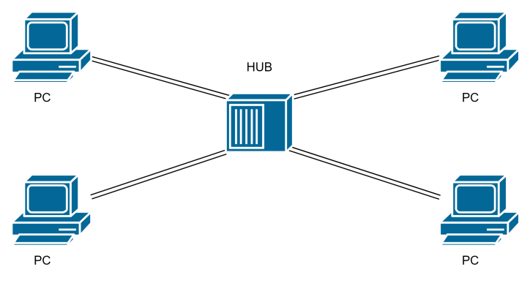

**2. Topology with a Switch**

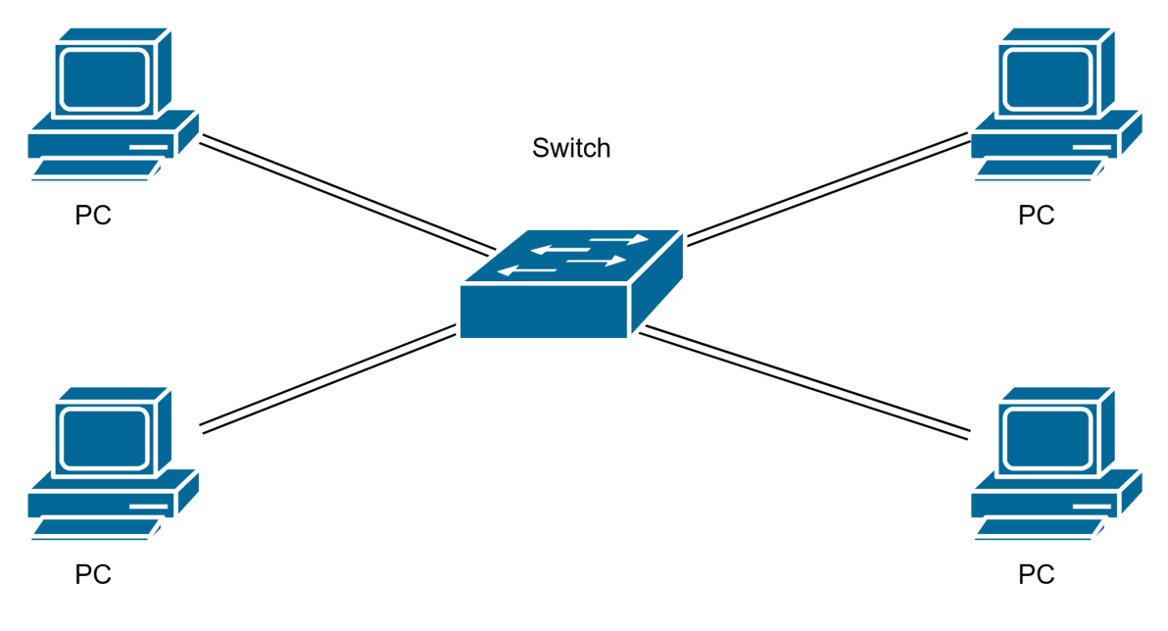

**3. Topology with two switches**

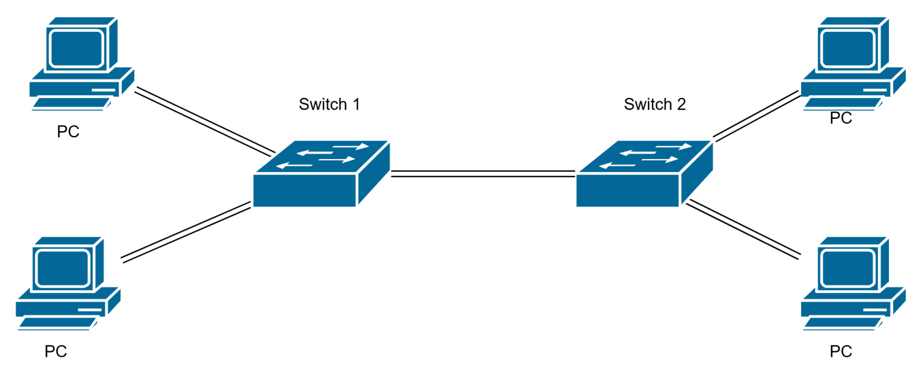

1. **Topology with 3 switches in a loop (Concept of STP)**

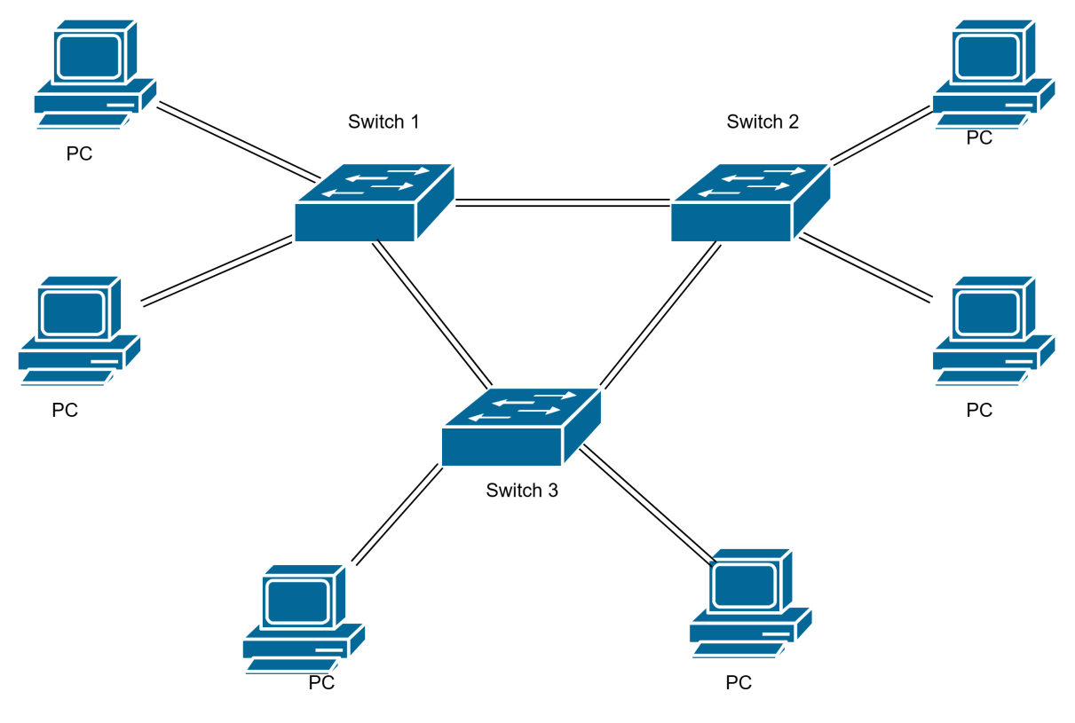

**Implementation details:**

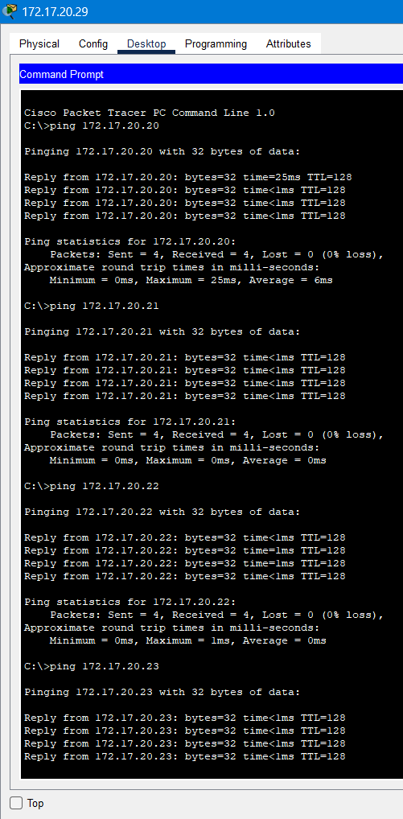

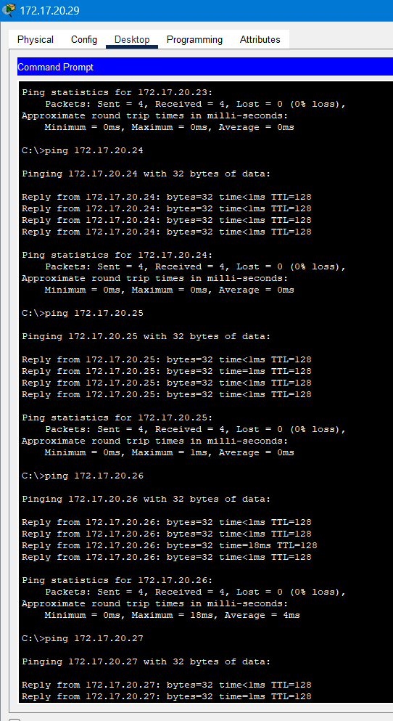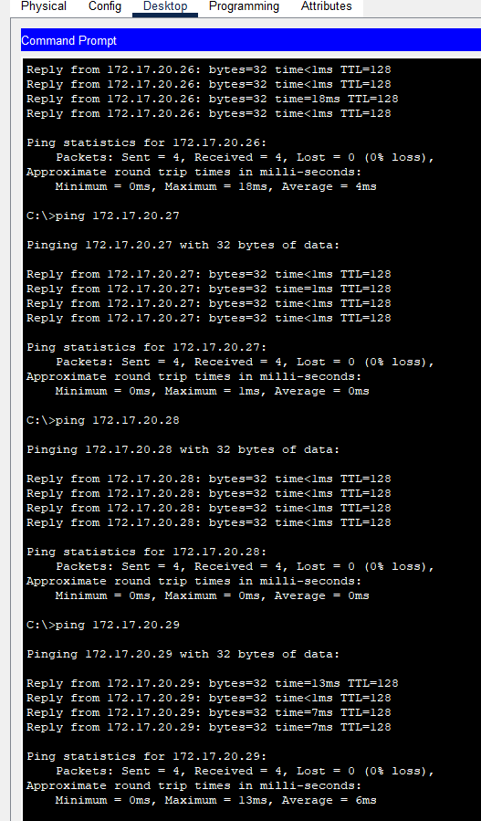

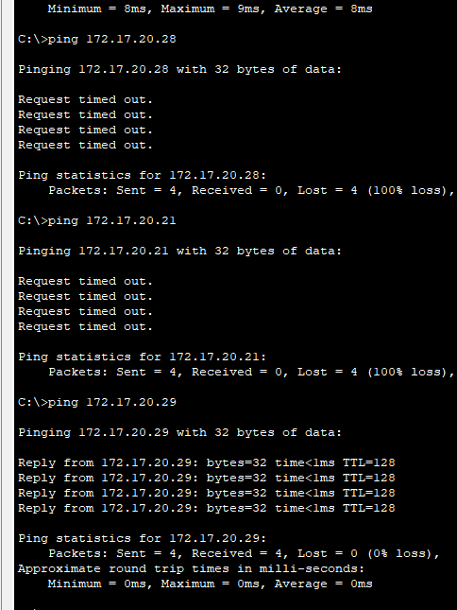

**CONCLUSION:**

In this experiment, we successfully built and configured a simple network topology using CISCO Packet Tracer. Through hands-on experience, we explored the fundamental aspects of network communication, including the setup and verification of network devices and their connections. By following a structured procedure, we configured IP addresses for PCs, established network connectivity, and used Simple PDU to simulate network traffic. This experiment provided valuable insights into the practical application of network topologies and the use of CISCO Packet Tracer as a simulation tool, reinforcing theoretical concepts with practical implementation.

**Post Lab Questions:**

1. **List features of CISCO Packet Tracer:**
   * Network simulation and visualization
   * Interactive learning environment
   * Supports various network devices and topologies
   * Assessment and collaboration tools
   * Real-time and simulation modes
   * Packet-level inspection and analysis
   * Cross-platform compatibility
2. **Explain the difference between the working of a Hub and a Switch in a given topology:**
   * **Hub:** A hub is a basic networking device that connects multiple PCs in a network. It operates at the physical layer (Layer 1) of the OSI model and broadcasts data to all connected devices, leading to potential collisions and inefficiency.
   * **Switch:** A switch operates at the data link layer (Layer 2) of the OSI model. It is more intelligent than a hub, as it forwards data only to the specific device that needs it, based on MAC addresses. This reduces collisions and increases network efficiency.
3. **Differentiate between LAN and VLAN:**
   * **LAN (Local Area Network):** A LAN is a network that connects devices within a limited area, such as a home, school, or office building. All devices in a LAN share the same broadcast domain.
   * **VLAN (Virtual Local Area Network):** A VLAN is a logical subgroup within a LAN that combines devices into separate broadcast domains. VLANs improve network performance and security by segregating network traffic, allowing devices on different VLANs to be logically separated even if they are on the same physical network.

**Date: 06/08/2024 Signature of faculty in-charge**